Once downloaded and installed, please make sure the program is set to run as administrator to do this, right click on the desktop icon, select PROPERTIES, then locate the tab called COMPATIBILITY, click it, and then click RUN AS ADMINISTRATOR and then click OK or APPLY

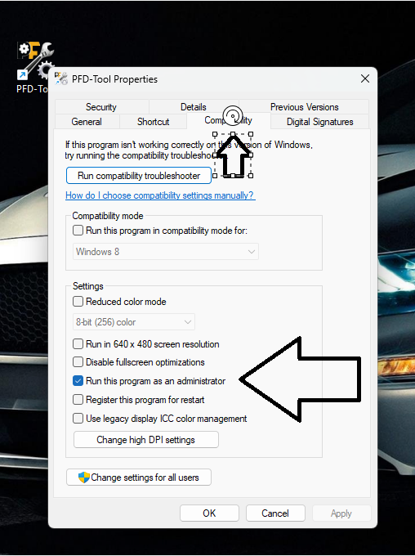

Open PFD-Tool and select FILE->SETTINGS
Click the rightmost tab REGISTER
Copy the Machine ID and email it to DonL@PocketfleetDS.com or open a support Ticket at WWW.PocketfleetDS.com/Tickets
And paste the key to a support ticket
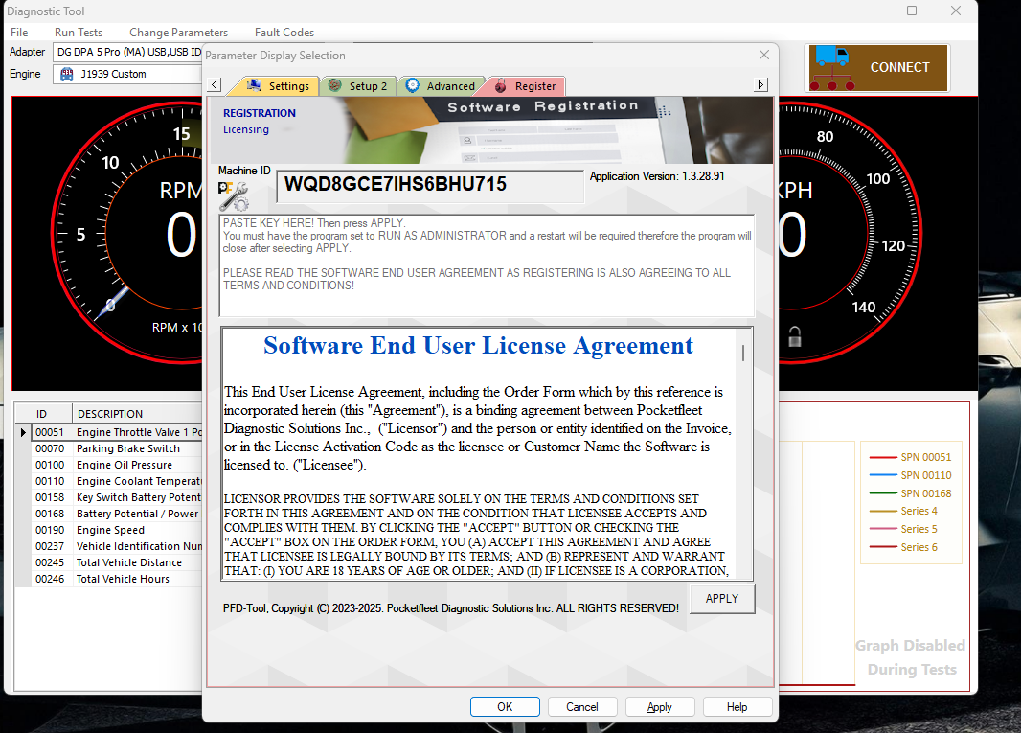
Once you get the key, copy it and paste it to the box below the machine ID and click APPLY then OK to exit or APPLY again to exit, restart the program
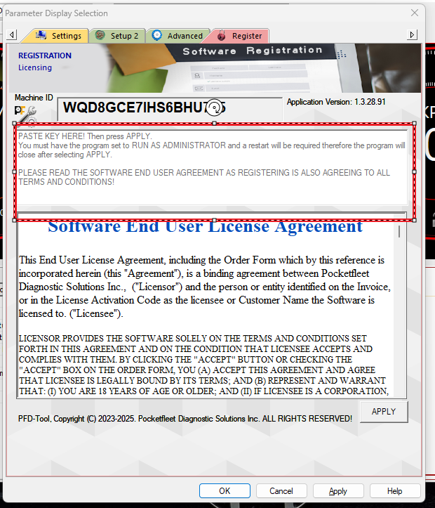
If all went well, the Lock in the Speedometer will be SILVER and open
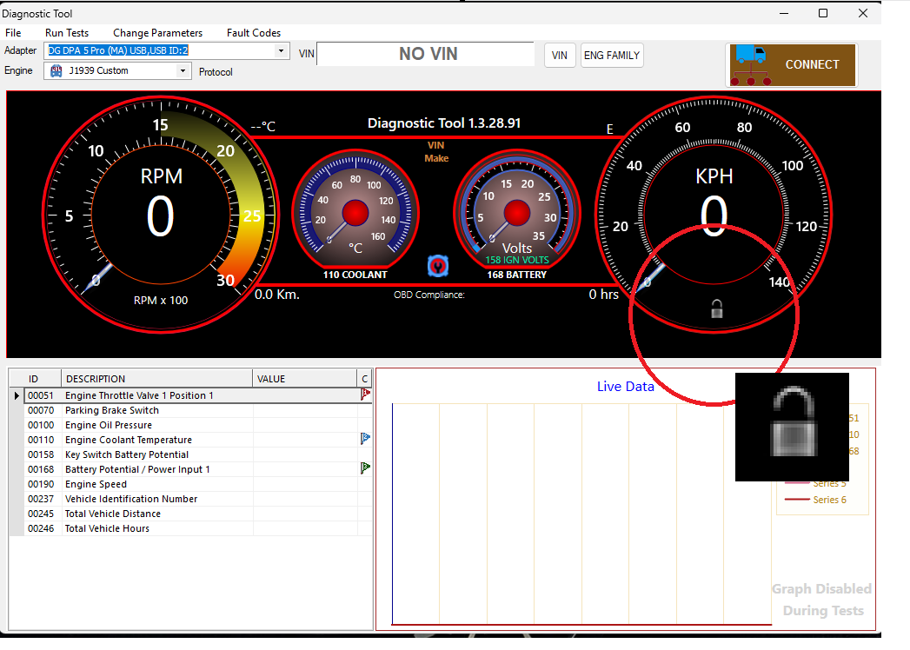
If not, Please make sure the program is set to run as admin or contact Support at DonL@PocketleetDS.com or open a support ticket at www.PocketfleetDS.com/Tickets
(Capitol T on Tickets all the rest lower case.)
There is a link on the support website.

